**Student Housing App**

**Final Project Report**



**Date:** 13/06/2022

**Group:** Group S02-01

**Group Members:** Yoshua Kock – 4452968

Renis Hila – 4506626

Guleesh Spithorst- 3680932

**Git:** https://git.fhict.nl/I484075/s02-02-student-housing-bv

**Version: Final**

**Contents**

1. **PROJECT DEFINITION………………………………………………………………………………………………………………3**
2. **Project Background…………………………………………………………………………………………………….3**
3. **Problem Definition……………………………………………………………………………………………………..3**
4. **Project Goal……………………………………………………………………………………………………………….3**
5. **Project Deliverables……………………………………………………………………………………………………4**
6. **PROJECT STRUCTURE ORGANIZATION…………………………………………………………………………………….5**
7. **Way of working………………………………………………………………………………………………………….5**
8. **Group work progress………………………………………………………………………………………………….6**
9. **Step by step……………………………………………………………………………………………………………….6**
10. **Project conclusion……………………………………………………………………………………………………..7**
11. **INDIVIDUAL REFLECTION AND EVALUATION……………………………………………………………………………7**
12. **RISK ASSESSMENT…..………………………………………………………………………………………………………………7**
13. **PLANNING………………………………………………………………………………………………………………………………8**
14. **PROJECT DEFINITION**
    1. **Project Background**

Student Housing BV owns different buildings where students can stay during their study in the Netherlands. Their buildings are composed of rooms, which are rented by the students, but also shared facilities such as toilets, bathrooms, kitchens, hallways, storage spaces, etc. For some time, there have been complaints from the students related to:

* Appointed persons not cleaning the shared facilities.
* Groceries are not done or paid for shared items such as toilet paper, dish soap, etc.
* Garbage disposal is not done on time.
* Unannounced parties, gatherings, etc.
  1. **Problem Definition**

Student Housing BV wants to offer their clients a software solution to better arrange day-to-day

situations and hopefully this will reduce the number of issues they face.

Student Housing BV envisions an application where their clients can record and see agreements made between them, but also the possibility to see the house rules and to file complaints anonymously. Every so often Student Housing BV will have one of their employees go by the buildings to update the rules and gather any complaints. They encourage additional functionalities and suggestions as long as it does not endanger the delivery of the application on time.

* 1. **Project Goal**

The project goal is to create an application, using Visual Studio ‘Windows Forms’, which all the tenants in a room and admin, being the landlord, can use. This will help with the communication between tenant and landlord.

* 1. **Project Deliverables**

In this project, the products that we will create are:

* A Database that will store the information of each user/tenant which will be used by the owner/admin.
* Separate app views for the tenant and the admin.
* Complaints tab, where tenants discuss major and minor issues with the admin.
* Task tabs, a way to assign different tasks to different tenants which will be easier to manage.
* Announcement tab, where tenants or admin can give their announcements to the house.
* Shopping tab, where tenants can request items to the grocery list where then the tenant, with the given task to do grocery shopping, will have to fetch the requested items for each tenant.

1. **PROJECT STRUCTURE ORGANIZATION**
   1. **Way of working**

Our ways for working on this project are:

* Visual Studio (Windows Forms) for the coding and design of the application

1. Admin Page:

* Add/Remove/Edit Tennant
* Add/Remove Building Layout
* Add/Remove Rules
* Make/See Announcement
* See/Answer Complaints (anonymous)
* Create/Assign Tasks
* See the agreements between tenants

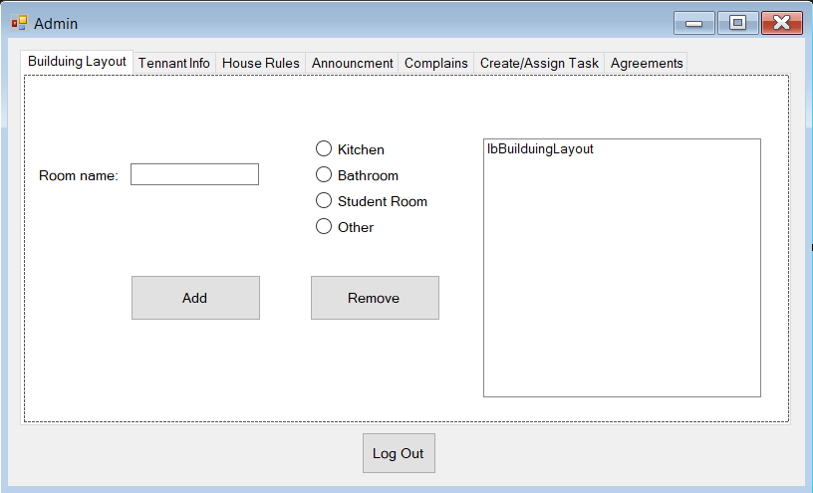

1. Tenant Page:

* See/Edit his profile
* See Rules
* Make/See Announcement
* Make (anonymous)/See the Complaints
* See his assigned task
* Add/Remove Shopping Items
* Make/See the agreements made with other tenants

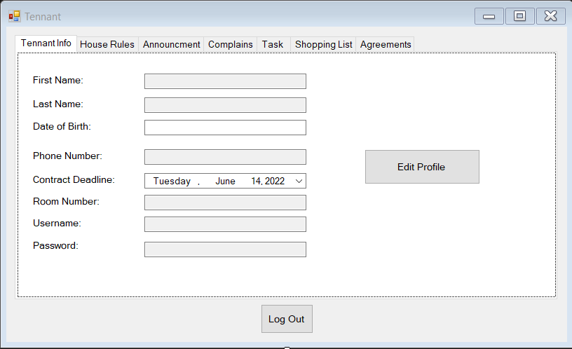

* Gitlabs to push our individual given task of the application
* SSMS for a database to the application **(optional)**
  1. **Group Work Progress**

This is how our work went throughout this 8 weeks:

* Group meetings every Monday to discuss the goal for the week
* Weekly goal to expectedly be completed before the next Monday
* Preferably work together at school. If late, members will need to let the others know. If absent, due to sickness or problem at home, let the other members know and continue to work at home
* Only push work in git repository if the current code works properly

**2.3 Step by step**

Steps that we followed to make this project:

1. Make the project plan
2. Create the prototype
3. Assign the tasks to the group members
4. Start implementing the code
5. Finish the design
6. Analyze our work
7. Deliver the final product

* 1. **Project conclusion**

We as a group, successfully managed to implement all the features as promised in the project plan document. Although we had a different way of working and approaches of solving the problems that the **“**Student Housing BV” was facing, we as group managed to deliver a functional application.

1. **INDIVIDUAL REFLECTION AND EVALUATION**

During the work for this project, I tried to give my best, to hand over the task I undertook to do, and to help as much as possible the group to successfully submit the project. The problems that each one of us has faced, we managed to overcome with the help of each other, making it possible to deliver a working project. I am satisfied and proud of the work done by Yoshua, Guleesh and myself.

**~Renis Hila**

This whole quartile I did my best to actively work in my group and to get my work done as required. Previously my largest issues were not being on time or not taking initiative to do my work, this has not been the case in this group. At the start I may have been absent from classes a bit but I did not hinder the project by making sure I communicated, did my required work and that I stepped it up shortly after. As a group we managed to help each other out when we got stuck and we managed to finish up the project without many issues.

What we could improve on is mostly structuring the code, due to us working on the project from the start of this part of the semester, we did not know everything early on and our coding standards were raised over time. This also means older parts of our program are not structured nicely, if we had more time we would have been able to improve on this by rewriting some parts of the code in order to have more parts that are currently implemented in form code, to be included inside the classes.

**~Guleesh Spithorst**

Working on this project has been a better experience than last advanced phase. I think I have been working hard even though I couldn’t make some deadlines in time but so far, I’m happy with what I have accomplish especially since I chose to work with text files. I am also satisfied with the work progress of the other group member. We’ve all been helping each other out with any problems that were encountered and, most importantly, we’ve all been working hard on this project.

**~Yoshua Kock**

1. **RISK ASSESSMENT**
2. **Group members being absent at school**  We agreed to preferably work together at school. A member being absent would halt the work progress especially if the group member doesn’t work on any of the given tasks.
3. **Group member not working**

To have the working progress go efficiently as possible everyone needs to be working at something at the same time. Having even one member of the group not working would drastically halt the work progress altogether.

1. **Assigned task not meeting deadline**

Assigned tasks are preferred to be done before the next week to follow the planning. Tasks not being done in time, due to reasons of time management or not understanding what to do, would halt the work progress.

1. **Project problems occurring midway the project deadline**

By chance, problems such as creative differences, a group member deciding not to come to school anymore or features that the group would like to implement, could happen midway at around week 14-15 and will have impact on finishing the project

|  |  |  |  |
| --- | --- | --- | --- |
| **Risk** | **Probability** | **Impact** | **Mitigation** |
| **1** | **Low** | **Harmful** | **If a member of the group is absent they will continue to work at home. Group meetings will still go on via Discord call.** |
| **2** | **Low** | **Extremely Harmful** | **Tasks are discussed and assigned to every member of the group at the beginning of each week with the “group deadline” being before the next week.** |
| **3** | **Likely** | **Harmful** | **Newly assigned tasks have a time limit of less than a week before deadlines. If by chance a group member is stuck with a task, the others would try and help so that the schedule is followed as smoothly as possible.** |
| **4** | **Low** | **Extremely Harmful** | **If features that the group wanted to implement didn't go according to plan, the group wouldn’t start on the project from scratch but leave that specific feature at the side until everything else works properly. If a group member decides to not come to school anymore, those given tasks will be split equally with the remaining members.** |

1. **PLANNING**

